1

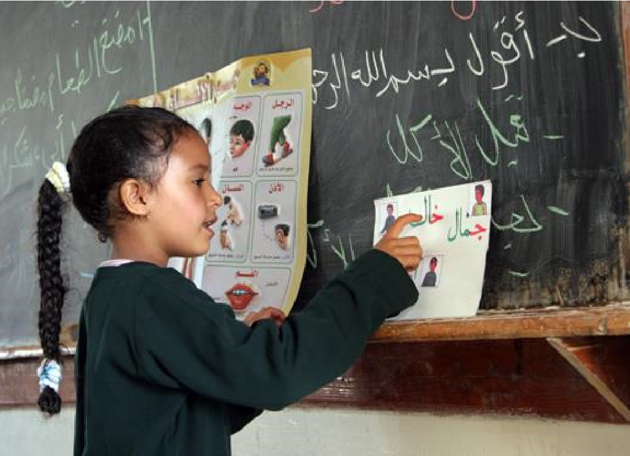
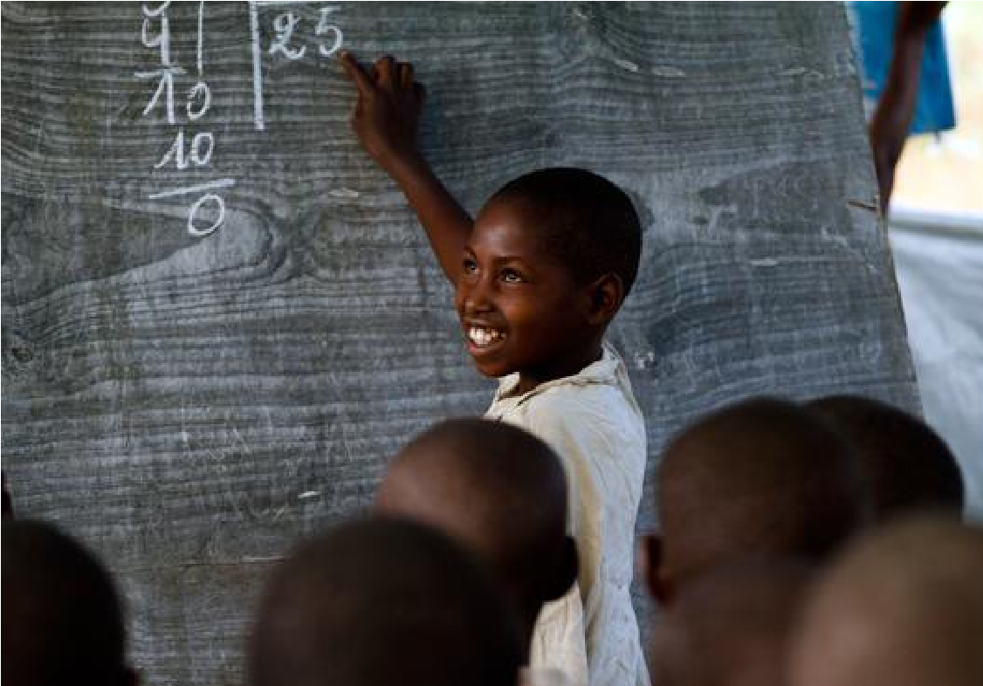

QUESTIONNNAIRE INPUT AND FEEDBACK FROM PARTICIPANTS

Minimum proficiency levels
(
MPLs):
outcomes of the
c
on
sensus
b
u
ilding m
e
etin
g

Proposal for Minimum Proficiency Levels

Minimum Proficiency Levels for Mathematics
Educational Level | Descriptor | Assessment PLD’s that align with the descriptor | MPL’s in the Assessments
Grades 2-3 | Students demonstrate skills in number sense and computation, shape recognition and spatial orientation. | PASEC 2014 – Level 1  PASEC 2014 – Level 2  TERCE 2014 – Level 2 | Level 2  Level 2
Grades 4-6 | Students demonstrate skills in number sense and computation, basic measurement, reading, interpreting, and constructing graphs, spatial orientation, and number patterns. | PASEC 2014 – Level 1  SACMEQ 2007 – Level 3  SACMEQ 2007 – Level 4  PILNA 2015 – Level 6  TERCE 2014 – Level 1  TIMSS 2015 –  Intermediate  International | Level 2  Level 3  Level 5  Level 2  Intermediate  International
Grades 8 & 9 | Students demonstrate skills in computation, application problems, matching tables and graphs, and making use of algebraic representations. | PISA 2015 – Level 2  TIMSS 2015 – Low  International | Level 2  Intermediate  International

Unpacking of the general descriptors
- Number sense: skills such as reading, writing, comparing, and ordering numbers.
- Computation: math problems presented without context, in arithmetic form, such as 38 + 67 or 23  92.
- Spatial orientation: position and direction on a diagram, map, or graph, often described by words such as “above”, “below”, “left”, “right”, “inside”, “outside”, etc.
- Application problems: also known as “word problems” or “story problems”, these are problems that are presented in context, without explicitly telling students which mathematical operation(s) to use.
- Algebraic representations: examples include expressions, equations, and inequalities, all of which contain one or more variables.

Minimum Proficiency Levels for Reading
Educational Level | Descriptor | Assessment PLDs that align with the descriptor | MPL in the assessment, if available
Grade 2 | They read and comprehend most of written words, particularly familiar ones, and extract explicit information from sentences. | • PASEC (Gr. 2) – Level 3 | • Level 3
Grade 3 | Students read aloud written words accurately and fluently. They understand the overall meaning of sentences and short texts. Students identify the texts’ topic. | • PISA-D – Level 1c | • Level 2
 |  | • Uwezo – Std. 2 (Story with meaning) | • Std. 2 (Story with meaning
 |  | • PASEC 2014 (Gr. 2) – Level 4 | • Level 3
 |  | • TERCE (Gr. 3) – Level 1 | • Level 2
 |  | • UNICEF MICS 6 –  Foundational  Reading Skills | • Foundational  Reading  Skills
 |  | • EGRA – Level 9 | • Not specified
 |  | • ASER – Std. 2 (story) | • Std. 2 (story)
Grades 4 & 6 | Students interpret and give some explanations about the main and secondary ideas in different types of texts. They establish connections between main ideas on a text and their personal experiences as well as general knowledge. | • SACMEQ 2007 –  Level 3 | • Level 3
 |  | • PASEC 2014 (Gr. 6) – Level 2 | • Level 3
 |  | • PIRLS 2011 – Low | • Low
 |  | • SERCE 2006 (Gr. 6) – Level 2 | • Level 1 (appears that way from Technical reports)
Grades 8 & 9 | Students establish connections between main ideas on different text types and the author´s intentions. They reflect and draw conclusions based on the text. | • PISA 2015 – Level 2 | • Level 2
 |  | • PILNA 2015 – Level 6 | • Level 4 (grade 4) and Level 5 (grade 5)
 |  | • TERCE 2014 (Gr. 3) – Level 3 | • Level 2
 |  | • PIRLS 11/16 - Intermediate | • Low
 |  | • SACMEQ 2007 –  Level 6 | • Level 3
Educational Level | Descriptor | Assessment PLDs that align with the descriptor | MPL in the assessment, if available
 |  | • TERCE 2014 (Gr. 6) – Level 1 | • Level 2

Unpacking of the general descriptors
- Familiar words: words that are part of the students’ vocabulary and that have been read before more than once.
- Explicit information: information that is presented in the text.
- Accuracy/Precision (in decoding): Correct recognition of the phonological form of a word based on its orthographic form.
- Fluency (in decoding): Presupposes accuracy and speed in word recognition. It can also include qualities such as volume (reading at a volume that is adequate to the instructions given or the audience), pace (adjusting the pace to the instructions, to improve precision or comprehension), expressiveness and tone (adjusting it to the audience’ characteristics, to the content and the characters).
- Short texts: texts that are between 60-80 words in length.
- Overall meaning of a text or sentence: refers to the most relevant information of the text.
- Topic of a text: an identified theme or subject.
- Interpret: Extract and recognize implicit and explicit information from a written sentence or text to relate it with other information or apply it to new situations or problem solving.
- Text types: narrative, descriptive, expository, procedural, verbal interaction, that report a central paragraph and complementary information and reference texts.
- General knowledge: previous knowledge that the student has in reference to everyday life and world affairs.
- Author´s intentions: may include the author´s choices (literary resources, title, words, etc.); the author´s feelings or motivations when/for writing, the author´s aim when writing, the author´s intentions when sharing a text in social media or publishing online.
- Reflect: Critically analyze and give an opinion about the information presented in a written sentence or text and the consequences the information may have.
- Draw conclusions: Generate conclusions from a text; generate conclusions about a topic considering different sources of information; generate conclusions about a character´s motivations or intentions.

8 Proposal of the minimum proficiency levels (MLPs)

that the proficiency scale, the alignment of the assessment program levels, and the minimum proficiency levels defined were satisfactory and after a final review by the partner participants, they should be brought to the GAML meeting.

Next Steps
The work will encompass two additional steps. First, one is the unpacking of the general PLD into examples of tasks that could help to operationalize the concept. The second steps is to add examples of items in current assessment that embed the proficiency that is required in the PLD with the potentiality to add some generic items as examples as well.

Appendix A. Assessment Programs whose PLDs were analyzed

 | Assessment Name | Type of Assessment | ^{Level of}  Assessment
ASER | Annual Status of Education Report | National Citizen-Led | Grades 2-3
EGRA | Early Grade Reading Assessment | Cross-national | Grades 2-3
PASEC | The Analysis Program of the CONFEMEN  Education Systems | Regional | Grades 2-3
TERCE | Third regional Comparative and Exploratory Study | Regional | Grades 2-3
UNICEF  MICS6 | UNICEF Multiple Indicator Cluster Service | Household Survey | Grades 2-3
Uwezo | Capacity Annual Learning Assessment | National Citizen-Led | Grades 2-3
PASEC | The Analysis Program of the CONFEMEN  Education Systems | Regional | Grades 4-6
PILNA | Pacific Islands Literacy ad Numeracy Assessment | Regional | Grades 4-6
PIRLS | Progress in International Reading Literacy Study | Regional | Grades 4-6
SACMEQ | Southern and Eastern African Consortium for  Monitoring Educational Quality | Regional | Grades 4-6
PILNA | Pacific Islands Literacy ad Numeracy Assessment | Regional | Grades 4-6
PIRLS | Progress in International Reading Literacy Study | Cross-national | Grades 4-6
TERCE | Third regional Comparative and Exploratory Study | Regional | Grades 4-6
TIMSS | Trends in International Mathematics and Science  Study | Cross-national | Grades 4-6
PISA,  PISA -D | Progress in International Reading Literacy Study | Cross-national | Grades 8-9
TIMSS | Trends in International Mathematics and Science  Study | Cross-national | Grades 8-9
Appendix B. Minimum Proficiency in Reading and in Mathematics in relation to Results on Existing Cross-national, Regional, and Citizen-led Tests.

READING
Education  Level | Descriptor | Assessment PLDs that align with the descriptor | MPL in the assessment, if available
Grades 8 & 9 | Students establish connections between main ideas on different text types and the author´s intentions. They reflect and draw conclusions based on the text. | • PISA 2015 – Level 2 | • Level 2
 |  | • PILNA 2015 – Level 6 | • Level 4 (grade  4) and Level 5  (grade 5)
 |  | • TERCE 2014 (Gr. 3) – Level 3 | • Level 2
 |  | • PIRLS 2011/16 – Intermediate | • Low
 |  | • SACMEQ 2007 – Level 6 | • Level 3
 |  | • TERCE 2014 (Gr. 6) – Level 1 | • Level 2
Grades 4 & 6 | Students interpret and give some explanations about the main and secondary ideas in different types of texts. They establish connections between main ideas on a text and their personal experiences as well as general knowledge. | • SACMEQ 2007 – Level 3 | • Level 3
 |  | • PASEC 2014 (Gr. 6) – Level 2 | • Level 3
 |  | • PIRLS 2011 – Low | • Low
 |  | • SERCE 2006 (Gr. 6) – Level 2 | • Level 1 (appears that way from Technical reports)
Grade 3 | Students read aloud written words accurately and fluently. They understand the overall meaning of sentences and short texts. Students identify the texts’ topic. | • PISA-D – Level 1c | • Level 2
 |  | • Uwezo – Std. 2 (Story with meaning) | • Std. 2 (Story with meaning
 |  | • PASEC 2014 (Gr. 2) – Level 4 | • Level 3
 |  | • TERCE (Gr. 3) – Level 1 | • Level 2
 |  | • UNICEF MICS 6 –  Foundational Reading  Skills | • Foundational Reading Skills
 |  | • EGRA – Level 9 | • Not specified
 |  | • ASER – Std. 2 (story) | • Std. 2 (story)
Grade 2 | Students read and comprehend most written words, particularly familiar ones, and extract explicit information from sentences. | • PASEC (Gr. 2) – Level 3 | • Level 3

MATHEMATIC S
Edu.  Level | Descriptor | Assessment PLDs that align with the descriptor | Minimum Proficiency Level in the assessment
Grades 8 &  9 | Students demonstrate skills in computation, application problems, matching tables and graphs, and making use of algebraic representations. | • PISA 2015 -- Level 2 | • Level 2
 |  | • TIMSS 2015 -- Low  International | • Intermediate International
Grades 4 & 6 | Students demonstrate skills in number sense and computation, basic measurement, reading, interpreting, and constructing graphs, spatial orientation, and number patterns. | • SACMEQ 2007 -- Level  3 | • Level 3
• SACMEQ 2007 -- Level
4
 |  | • PASEC 2014 -- Level 1 | • Level 2
 |  | • PILNA 2015 -- Level 6 | • Level 5
 |  | • TERCE 2014 -- Level 1 | • Level 2
 |  | • TIMSS 2015 -- intermediate international  benchmark | • Intermediate  international
Grade 2/3 | Students demonstrate skills in number sense and computation, shape recognition and spatial orientation. | • TERCE 2014 -- Level 2 | • Level 2
 |  | • PASEC 2014 -- Level 1 | • Level 2
 |  | • PASEC 2014 -- Level 2

